Referential / Lookup Check

Definition
# Source: AI Source: Provided by: [Data Path: Persons Table -> ID Column: 1, Name_En Column: Motasem Essam] -> From: [Chatgpt (GPT‑5 Mini)] on [12/10/2025]
A Referential Check ensures that data in one table or dataset correctly references data in another related table.
- Common in relational databases where relationships exist between tables (foreign keys and primary keys).
- Prevents orphaned records and maintains data integrity.
Key idea:
It’s like making sure an order references a valid customer — you can’t have an order for a customer who doesn’t exist in the customer table.

Characteristics
# Source: AI Source: Provided by: [Data Path: Persons Table -> ID Column: 1, Name_En Column: Motasem Essam] -> From: [Chatgpt (GPT‑5 Mini)] on [12/10/2025]
- Ensures referential integrity between related datasets or tables.
- Often implemented using foreign key constraints in databases.
- Prevents invalid references or broken links.
- Essential for multi-table relational data systems, like customer orders, inventory, HR, and financial systems.

Examples

1. Orders and Customers
# Source: AI Source: Provided by: [Data Path: Persons Table -> ID Column: 1, Name_En Column: Motasem Essam] -> From: [Chatgpt (GPT‑5 Mini)] on [12/10/2025]
Customer Table:
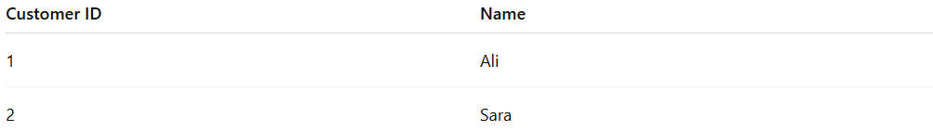
Customer ID | Name
1 | Ali
2 | Sara
Orders Table:
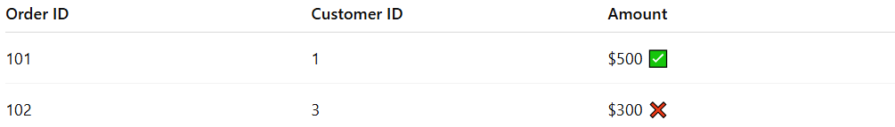
Order ID | Customer ID | Amount
101 | 1 | $500 ✅
102 | 3 | $300 ❌
Explanation:
Customer ID 3 does not exist in the customer table, so the referential check flags this record as invalid.

2. Students and Classes
# Source: AI Source: Provided by: [Data Path: Persons Table -> ID Column: 1, Name_En Column: Motasem Essam] -> From: [Chatgpt (GPT‑5 Mini)] on [12/10/2025]
Class Table:
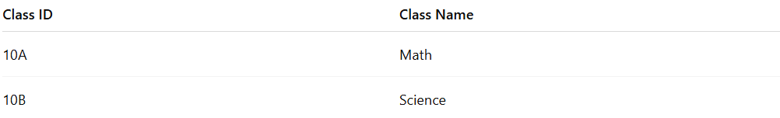
Class ID | Class Name
10A | Math
10B | Science
Student Table:
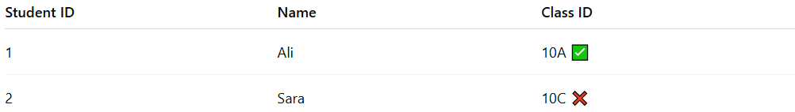
Student ID | Name | Class ID
1 | Ali | 10A ✅
2 | Sara | 10C ❌
Explanation:
Class 10C does not exist in the class table, so the system rejects or flags the record.

3. Products and Inventory
# Source: AI Source: Provided by: [Data Path: Persons Table -> ID Column: 1, Name_En Column: Motasem Essam] -> From: [Chatgpt (GPT‑5 Mini)] on [12/10/2025]
Products Table:
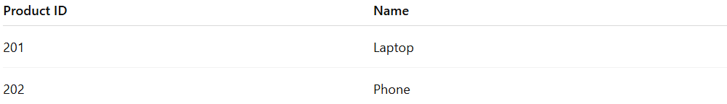
Product ID | Name
201 | Laptop
202 | Phone
Inventory Table:
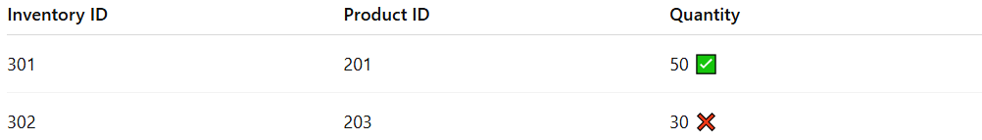
Inventory ID | Product ID | Quantity
301 | 201 | 50 ✅
302 | 203 | 30 ❌
Explanation:
Product 203 does not exist in the products table, so the referential check prevents invalid inventory records.

4. Employees and Departments
# Source: AI Source: Provided by: [Data Path: Persons Table -> ID Column: 1, Name_En Column: Motasem Essam] -> From: [Chatgpt (GPT‑5 Mini)] on [12/10/2025]
Department Table:
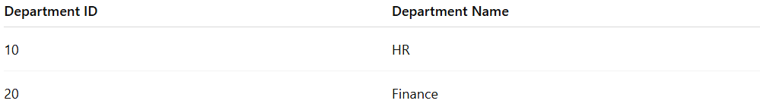
Department ID | Department Name
10 | HR
20 | Finance
Employee Table:
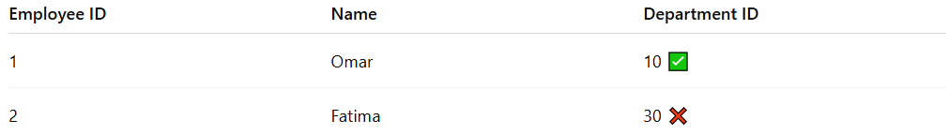
Employee ID | Name | Department ID
1 | Omar | 10 ✅
2 | Fatima | 30 ❌
Explanation:
Department 30 does not exist, so the system flags this employee record.

Advantages
# Source: AI Source: Provided by: [Data Path: Persons Table -> ID Column: 1, Name_En Column: Motasem Essam] -> From: [Chatgpt (GPT‑5 Mini)] on [12/10/2025]
- Ensures data consistency across related tables.
- Prevents orphaned or invalid records that can break systems or reports.
- Essential for database reliability and integrity.
- Reduces errors in multi-table operations like joins, queries, and reports.

Disadvantages
# Source: AI Source: Provided by: [Data Path: Persons Table -> ID Column: 1, Name_En Column: Motasem Essam] -> From: [Chatgpt (GPT‑5 Mini)] on [12/10/2025]
- Can slow down insert or update operations due to integrity checks.
- Requires properly defined relationships and constraints; misconfiguration can block valid data.
- Harder to implement in non-relational systems.
- May require additional maintenance when table structures change.

Example Section
# Source: AI Source: Provided by: [Data Path: Persons Table -> ID Column: 1, Name_En Column: Motasem Essam] -> From: [Chatgpt (GPT‑5 Mini)] on [12/10/2025]
Order and Customer database example:
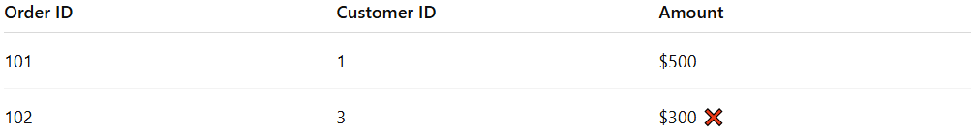
Order ID | Customer ID | Amount
101 | 1 | $500
102 | 3 | $300 ❌
- Order 102 references a non-existent customer.
- Referential check flags this error, preventing the order from being saved until corrected.

